8/13/2026
ASSIGNMENT DAY1
Hardware & Software Tools for Computer Troubleshooting.
YAGNIK GHETIYA
TASK 1.
- List three real-life scenarios where a multimeter would be used to troubleshoot a computer or smartphone issue, and explain in one line how the multimeter helps in each case.

- Checking a Computer Power Supply: A multimeter checks the PSU voltage to make sure it is supplying the correct power to the computer.

- Testing a Smartphone Battery: A multimeter measures the battery voltage to find out whether the battery is working properly or is faulty.

- Finding a Broken Circuit: A multimeter checks continuity in the motherboard or phone circuit to detect broken connections or short circuits.

TASK 2.
- Watch a short YouTube video demo of a POST card in action (search for 'POST card motherboard test'), then write a brief summary (3-4 lines) describing what the POST card displays and what problem it helped identify in the video. Focus on the codes shown and how they relate to hardware issues.

- The POST card displays hexadecimal codes during the computer’s startup, showing which hardware is being tested.
In the demo, codes such as 3387, 2900 and AA00 showed the BIOS and boot process progressing successfully.
The codes help identify hardware problems by showing where the POST process stops or fails.
This makes it easier to locate issues related to the CPU, RAM, motherboard or other hardware.

TASK 3.
- Change your device's IP address from 'Obtain IP automatically' (DHCP) to a static IP in the same range as your router (for example, set it to 192.168.1.50 if your router is 192.168.1.1), and test if you still have internet access. Constraint: Remember to revert to automatic/DHCP after testing to avoid network issues.

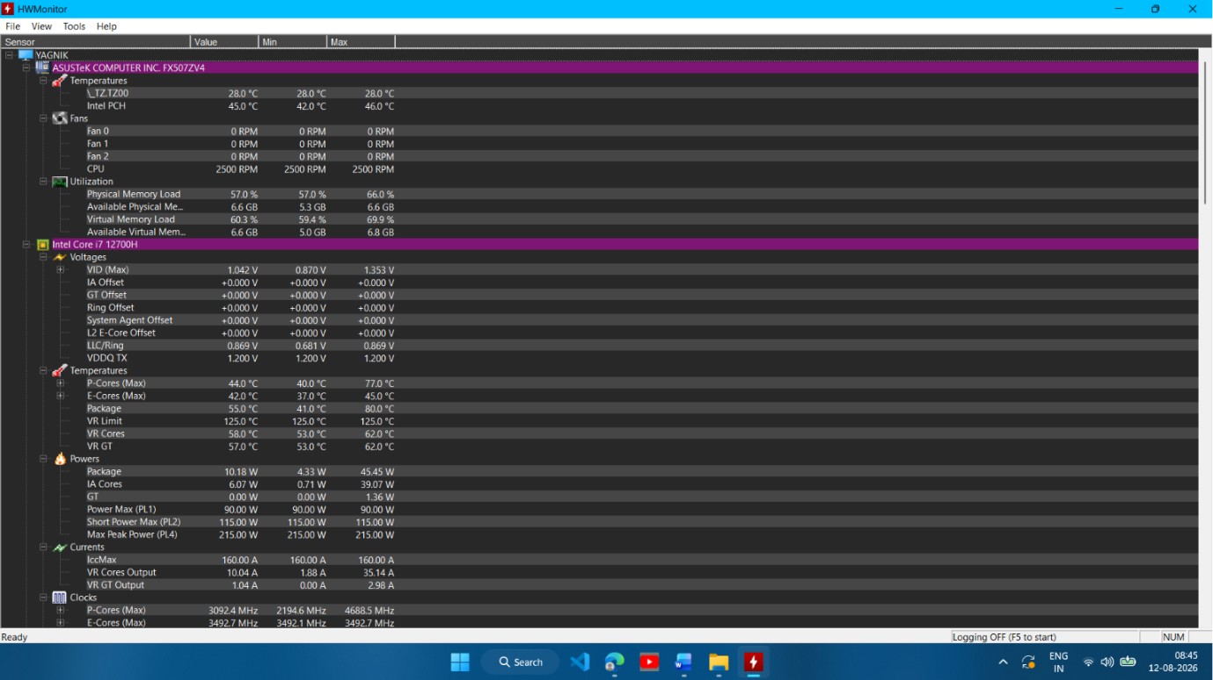
Figure : HW Monitor Dashboard Showing System Health Details.

Explanation :
- I installed and ran HW Monitor to check my laptop’s system health. The dashboard displays important details such as CPU temperature, voltage, power, fan speed, memory usage, and processor speed. These readings help identify overheating, power, or hardware-related issues.

TASK 4.
- Compare the use of a multimeter, POST card, and software diagnostics by creating a table with three columns (Tool, What it checks, Example Problem Detected) and fill in at least one example for each tool.

- Comparison of Multimeter, POST Card, and Software Diagnostics:

Tool | What it checks | Example Problem Detected
Multimeter | Voltage, current, and continuity | Faulty power supply
POST Card | Hardware status using POST codes | RAM or motherboard failure
Software Diagnostics | Temperature, storage, and system health | CPU overheating or SSD failure

